Mini DropBox

Requirement Specification:

Mini Dropbox:

Mini Dropbox | Description
Users | Users should easily be able to upload, download, delete, and view files. Files should be synchronised across multiple devices. Accessible from various platforms (web). Ability for users to create, manage, and delete their folders.

Platform Requirements:

mobile App | Requirement | Priority
 | iPhone | Essential
 | App store | Essential
 | Internet connection | Essential
Website | Laptop/PC | Essential
 | Web browser | Essential
 | Internet connection | Essential
Functional Requirements:

ID | Requirement Name | Description | Priority
FR1 | Registration | The application should allow users to register using their email and OTP. and give their personal details. | Essential
FR2 | Login | The application should allow users to login using their email and OTP if they already have an account otherwise create a new account | Essential
FR3 | Logout | The application should allow users to logout of their account | Essential
FR4 | Create and delete the folders | The user can login into the website and create the folders. If the user wants to delete the folder then they can click on the delete button folder should be deleted. The user can view the created folders. | Essential
FR5 | Upload File | The user can upload the file into the website. | Essential
FR6 | Download File | The user can download the uploaded file. | Essential
FR7 | Embedded Files | The user can embed the file | Recommended
FR8 | Share files | The user can share the files to another registered user. | Optional
Non-Functional Requirements:
Requirements concerning performance, storage capacity, code quality, documentation, accessibility, security, dependability, scalability, portability, user interface usability, etc. are a few examples of non-functional requirements.

ID | Requirement | Description
NFR1 | Performance | The application must fetch and load files data within five seconds.
NFR2 | Authentication | The application must prevent unauthorised access by providing two-factor authentication during the signing-up and logging-in processes.
NFR3 | Modularity | The application must be separated into distinct modules using the MVVM design pattern.
NFR4 | Interoperability | The application must be able to share and receive information from the Safari extension.

System Architecture Diagram:
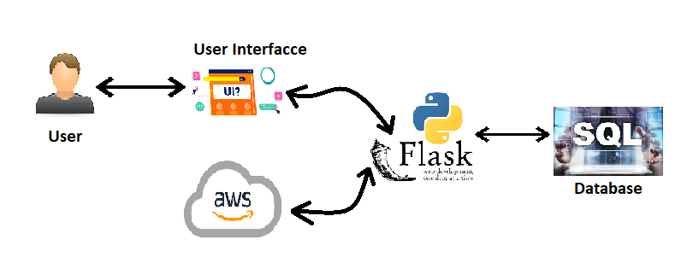

System Architecture Diagram Example:
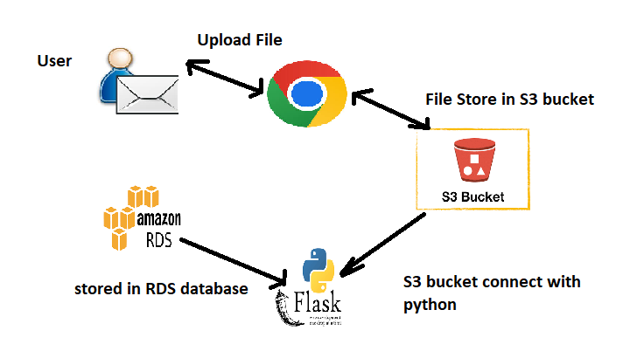

Logical Model Design:
Use Case Diagram:
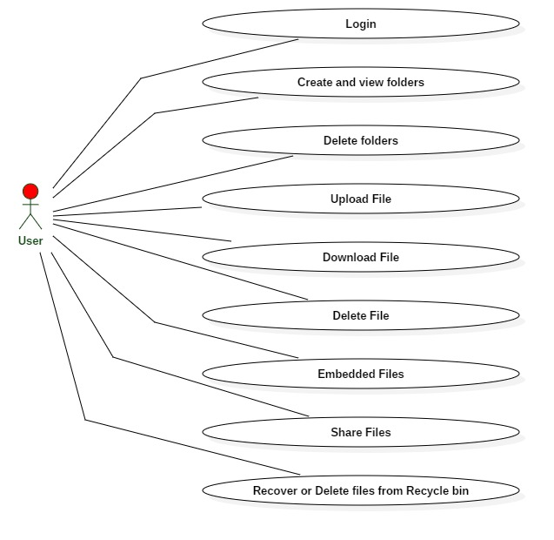
Activity Diagram:
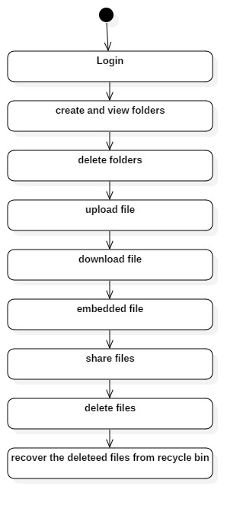
Class Diagram:
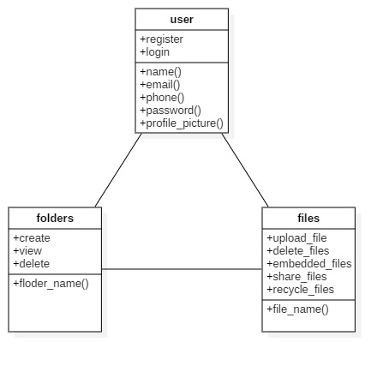
Sequence Diagram:
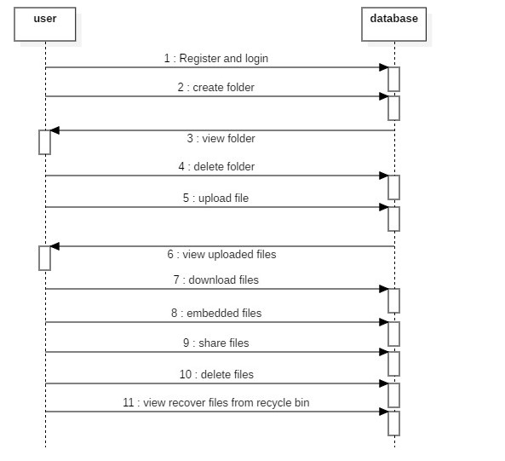

ER Diagram:
